🏍️ Motorcycle OBD (On-Board Diagnostics)
- OBD ports exist on motorcycles much like cars. They allow mechanics (and riders with the right tools) to plug in diagnostic scanners.
- Through OBD, you can read fault codes, sensor data, and ECU information.
- Many aftermarket tools (e.g., GS-911 for BMW, HealTech OBD readers) are available for riders to troubleshoot or customize their bikes.
🔌 Motorcycle CAN Bus (Controller Area Network)
- CAN bus is the communication backbone of modern motorcycles. Instead of each component having its own wiring, CAN bus allows devices to share a common data line.
- It connects systems like:
  - ABS brakes
  - Traction control
  - Lighting and indicators
  - Immobilizer and dashboard
- Benefits:
  - Reduces wiring complexity and weight.
  - Enables advanced features (ride modes, electronic suspension, adaptive headlights).
  - Provides enhanced diagnostics through OBD scanners.
- Manufacturers using CAN bus: Ducati (first partial use in 2002), BMW (full CAN bus in 2004 GS models), and now nearly all major Japanese and European brands, plus Harley-Davidson.
⚙️ Why It Matters for Riders
- Customization: Adding accessories (aux lights, horns, cameras) requires CAN bus awareness, since the system monitors loads and may shut down circuits if it detects anomalies.
- Diagnostics: CAN bus makes fault finding easier with the right tools, but harder for DIY wiring hacks. For example, unplugging a tail light might trigger safety fallbacks like activating indicators.
- Future-proofing: As bikes get more electronic, CAN bus and OBD are essential for both maintenance and upgrades.
✅ In short: Motorcycles today absolutely have OBD-like diagnostic ports and CAN bus systems, just like cars. They’re central to modern bike electronics, enabling advanced features, easier diagnostics, and more complex customization.
Michel, since you’re a system architect with a passion for automation and modular design, you’d probably appreciate how CAN bus in bikes mirrors enterprise infrastructure: a centralized communication backbone that reduces complexity but requires careful integration when extending functionality. Would you like me to show you how riders typically tap into motorcycle CAN bus for custom scripting or automation (like logging ride data or controlling accessories)?

🏍️ Data Sources for Speedometer & Motor Stats
- CAN Bus Integration
  - Most modern motorcycles expose speed, RPM, throttle position, ABS status, and other sensor data over CAN bus.
  - You’ll need a CAN bus interface module (e.g., Arduino with CAN shield, Raspberry Pi with MCP2515, or dedicated motorcycle CAN adapters).
  - Manufacturers often use proprietary CAN IDs, so reverse engineering or manufacturer documentation is required.
- OBD-II (Motorcycle OBD)
  - Many bikes have an OBD-II port (often a 6-pin or 4-pin connector instead of the car-standard 16-pin).
  - With an OBD-II reader, you can access ECU data like engine RPM, coolant temperature, throttle position, and fault codes.
- Direct Sensor Taps
- For older bikes without CAN bus, you may need to tap into analog signals (speed sensor, tachometer wire, etc.) and digitize them.
📟 Display Options
- TFT LCD or OLED Panels
  - Automotive-grade TFT displays are common for dashboards.
  - Consider sunlight readability, vibration resistance, and waterproofing.
- Embedded Controllers
  - Raspberry Pi, STM32, or ESP32 can drive the display and handle CAN bus parsing.
  - Pi gives you flexibility for rendering rich UIs (speedometer graphics, manuals, menus).
- UI Design
- Speedometer (digital or analog-style dial).
- Engine stats (RPM, temperature, fuel, gear).
- Alerts (ABS, traction control, check engine).
- Menu system for accessing the user manual.
📖 User Manual Integration
- Digital Manual Storage
  - Store the manual as PDF, HTML, or structured text on the device.
  - Provide a menu-driven interface for browsing sections.
- Search & Contextual Help
  - Add search functionality so riders can quickly find “ABS troubleshooting” or “oil change interval.”
  - Contextual linking: if a warning light appears, the system can auto-open the relevant manual section.
- Offline Access
- Ensure the manual is stored locally (no reliance on internet).
⚙️ Challenges & Considerations
- Reverse Engineering CAN IDs
  - Each manufacturer uses different CAN message mappings. You may need sniffing tools (like SavvyCAN or CANalyzer) to decode.
- Safety & Compliance
  - Display must not distract the rider. Keep critical stats always visible, and manual access only when stationary.
- Power & Mounting
  - Motorcycle electrical systems are noisy; use DC-DC converters with filtering.
  - Ensure vibration-proof mounting and waterproof casing (IP65+ recommended).
- Expandability
- Modular design: allow future add-ons like GPS navigation, ride logging, or Bluetooth phone integration.
🔧 Typical Hardware Stack
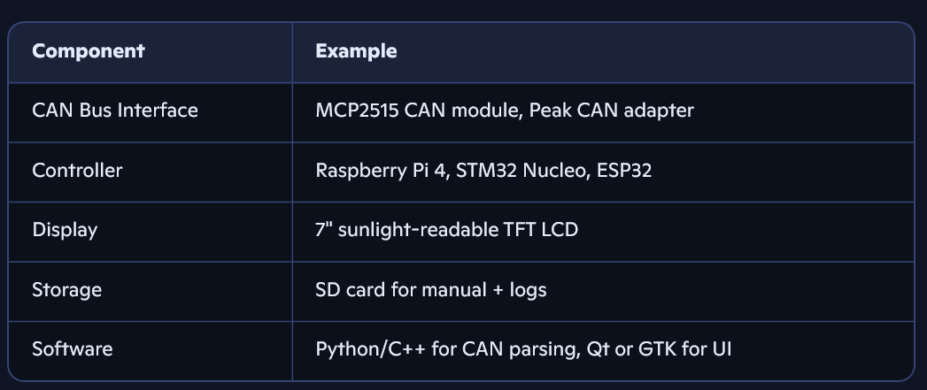

⚡ Why ESP32 Fits
- Dual-core MCU with Wi-Fi + Bluetooth → perfect for future expandability (e.g., phone pairing, OTA updates).
- Plenty of GPIOs for CAN bus transceivers, sensors, and display control.
- Libraries & ecosystem: Mature support for TFT/OLED touchscreens, CAN bus, and UI frameworks.
- Low power draw → important for motorcycle electrical systems.
📟 Touchscreen Options
- TFT LCD (SPI or parallel interface)
  - 3.5"–7" sunlight-readable TFTs are common.
  - Capacitive touch is more modern and glove-friendly (though resistive works better with thick gloves).
- Popular modules:
- ILI9341 (2.8–3.5") for compact dashboards.
- RA8875 or FT81x (larger, higher resolution, with hardware acceleration).
- Nextion HMI displays (integrated controller, easier UI design).
🔌 CAN Bus Integration
- ESP32 doesn’t have native CAN, but you can add a CAN transceiver module:
  - MCP2515 (SPI-based, common and cheap).
  - SN65HVD230 (direct CAN transceiver for ESP32).
- Use libraries like ESP32CAN or Arduino-ESP32 CAN driver to decode messages.
- You’ll need to map manufacturer-specific CAN IDs for speed, RPM, etc. (reverse engineering or documentation).
🖥️ UI Architecture
- Speedometer:
  - Digital (large numeric) or analog-style dial with animated needle.
- Motor stats:
  - RPM, coolant temp, fuel level, gear indicator.
- User manual:
  - Store manual in flash/SD card.
  - Render as text pages with scroll + search.
  - Contextual linking: if a warning light triggers, auto-open relevant manual section.
- Navigation:
- Touch menus with large buttons (glove-friendly).
- Dark mode for night riding.
⚙️ Suggested Hardware Stack
🚀 Next Steps
- Prototype on bench: ESP32 + CAN transceiver + TFT touchscreen.
- Sniff CAN bus on target motorcycle to identify IDs for speed, RPM, etc.
- Design UI mockups (speedometer, stats, manual browser).
- Iterate: add logging, themes, and modularity.
Michel, given your love for modular, themeable GUIs and error-proof scripting, you could design the UI framework almost like your PowerShell GUIs:
- Theme control (day/night modes).
- Modular widgets (speedometer, stats, manual viewer).
- Logging (ride data to CSV/JSON on SD).

